**AI-Powered Personal Tutor**

Intel® Unnati Industrial Training – 2025

**Submitted By:**

**Team Leader:** Chukka Prasadu

**Team Members:** Bogyam Jagadeesh

Ghantasala V N L S Satya Ganesh

**Guided By:**

**Dr. V. V. A. S. Lakshmi**

**Submitted To:**

Intel® Unnati Industrial Training Program – 2025

NARASARAOPETA ENGINEERING COLLEGE

DEPARTMENT OF CSE (CYBER SECURITY)

**Year: 2025**

**ABSTRACT**

In today's fast-paced digital era, personalized learning platforms have revolutionized the education system by providing customized learning experiences tailored to individual needs. This project presents the development of a Personalized Learning Platform that leverages AI-driven analytics to enhance user engagement, optimize content delivery, and track learner progress. The platform integrates various learning resources, adaptive assessments, and interactive modules to cater to diverse learning styles.

Key features include intelligent content recommendations, real-time progress tracking, interactive learning sessions, and performance analytics. The system utilizes machine learning algorithms to analyze user behavior and provide adaptive learning paths. Additionally, it supports multimodal learning, incorporating text, audio, and video-based materials for an enriched educational experience.

This project aims to bridge the gap between traditional education and technology-driven solutions, ensuring a more efficient and personalized approach to learning. By implementing this platform, institutions, educators, and learners can benefit from improved retention rates, targeted learning strategies, and a data-driven approach to education. The proposed system ultimately fosters a more effective and engaging learning environment, making education accessible and customized for every learner.

**TABLE OF CONTENTS**

1. Introduction  
   1.1 Overview  
   1.2 Problem Statement  
   1.3 Scope of the Project  
   1.4 Objectives
2. Literature Survey / Existing System  
   2.1 Traditional Learning Methods  
   2.2 Limitations of Existing Learning Platforms  
   2.3 The Need for AI-Based Personalized Learning
3. **System Requirements Analysis**  
   3.1 Functional Requirements  
   3.2 Nonfunctional Requirements
4. **System Design**  
   4.1 Architectural Design  
   4.2 UML Diagrams  
   4.2.1 Sequence Diagram  
   4.2.2 Use Case Diagram
5. **Proposed AI-Powered Personalized Learning Platform**  
   5.1 Overview of the Personalized Tutor System  
   5.2 Core Functionalities  
   5.2.1 Adaptive Learning Module  
   5.2.2 AI-Based Content Recommendation System  
   5.2.3 Real-Time Student Performance Analysis  
   5.3 Working Mechanism
6. **Implementation**  
   6.1 Architectural Overview  
   6.2 Data Collection & Model Training  
   6.3 AI Model Training for Adaptive Learning  
   6.4 System Development  
   6.4.1 Adaptive Learning Engine  
   6.4.2 Content Recommendation Module  
   6.4.3 Student Performance Analysis Module  
   6.4.4 AI-Powered Feedback System  
   6.5 User Interface Development  
   6.5.1 Designing an Interactive Dashboard  
   6.5.2 Implementing a Voice and Text-Based Tutor  
   6.6 Real-Time Learning Assistance
7. **Testing and Debugging**  
   7.1 Simulating Different Learning Scenarios  
   7.2 User Testing and Feedback  
   7.3 Performance Evaluation of AI Recommendations
8. **Experimentation & Result Analysis**  
   8.1 Output Screens / Results  
   8.1.1 Personalized Learning Paths  
   8.1.2 Adaptive Content Delivery
9. **Conclusion and Future Enhancements**  
   9.1 Summary of the Project  
   9.2 Limitations  
   9.3 Future Enhancements

**CHAPTER -1 INTRODUCTION**

# INTRODUCTION

### Overview

In the digital age, traditional learning methods often fail to cater to the diverse learning needs of students. A **Personalized Learning Platform** enhances the educational experience by adapting content based on a student's knowledge, performance, and learning style. This project leverages **Artificial Intelligence (AI)** to offer a customized learning journey, ensuring that students receive the right level of instruction based on their capabilities. The system incorporates features such as **adaptive assessments, AI-driven content recommendations, real-time performance tracking, and interactive doubt assistance** through voice and text-based interaction.

The platform aims to **bridge the gap between traditional and modern e-learning approaches**, offering a dynamic, student-centered education system that ensures **effective knowledge acquisition and retention**.

### Problem Statement

### Many existing online learning platforms follow a one-size-fits-all approach, where students are expected to follow a predefined curriculum regardless of their prior knowledge or learning speed. This method results in:

### Lack of personalization, making it difficult for students to grasp concepts at their own pace.

### Inefficient learning pathways, where advanced students may have to go through redundant content, while beginners struggle to keep up.

### Limited real-time assistance, making it challenging for students to resolve doubts efficiently.

### To address these challenges, this project introduces a Personalized Learning Platform that adapts course content dynamically based on the student's performance and knowledge level, ensuring an efficient and interactive learning experience.

### Scope of the Project

### The scope of this project covers the development of an AI-powered Personalized Learning Platform with the following functionalities:

### Student Authentication & Profile Management – Secure login/signup for users.

### Adaptive Course Structuring – Courses adjust based on a student’s prior knowledge through pre-assessments.

### Dynamic Content Delivery – AI recommends basic, intermediate, or advanced modules depending on performance.

### Real-Time Progress Tracking – Continuous assessment after every module, allowing AI to guide the student's learning path.

### Doubt Assistance via AI Chatbot – Students can interact with an AI-driven tutor via text or voice to get answers.

### Interactive and Engaging UI – A user-friendly dashboard displaying course progress and analytics.

### This project aims to create a system that enhances student engagement, optimizes learning efficiency, and makes quality education accessible to all.

### Objectives

The primary objectives of this project are:

* To **develop an AI-powered learning platform** that personalizes content based on student performance.
* To **integrate pre-assessment and continuous evaluation** for effective learning adaptation.
* To **implement an AI-based doubt assistance system** using text and voice interactions.
* To **provide real-time analytics and feedback** to track and improve student performance.
* To **enhance learning engagement** through an **intuitive and interactive** user experience.

By achieving these objectives, the platform will **revolutionize the e-learning experience** and promote **efficient, student-centric education**.

**CHAPTER-2**

**Literature Survey / Existing System**

## Literature Survey / Existing System

1. **Literature Survey / Existing System**

**2.1 Traditional Learning Methods**

Traditional learning methods primarily involve classroom-based teaching, where instructors deliver content in a standardized manner. This method relies on a fixed curriculum, with little to no consideration of individual students' learning pace, prior knowledge, or personal interests.

Key characteristics of traditional learning:

* Instructor-Centered Approach – The teacher delivers the lesson, and students are passive recipients.
* Fixed Learning Pace – All students follow the same curriculum, irrespective of their understanding level.
* Limited Flexibility – No customization based on individual student needs.
* Manual Assessments – Evaluations are conducted at the end of the course, offering no real-time feedback.

While traditional learning has been effective for many years, it lacks adaptability to modern-day digital advancements and personalized learning needs.

### Limitations of the Existing Systems

### Modern e-learning platforms such as Coursera, Udemy, and Khan Academy provide online education, but they still have several limitations:

### One-Size-Fits-All Approach – Most platforms offer static content that does not adapt based on a student’s prior knowledge.

### Lack of Real-Time Adaptation – Courses are pre-structured without dynamic difficulty adjustments based on student performance.

### Limited Engagement – Many platforms lack interactive elements, making learning less engaging.

### Inefficient Doubt Resolution – Students rely on discussion forums, which often result in delayed responses.

### No AI-Based Feedback Mechanism – There is no real-time assessment to adjust content or suggest improvements.

### Due to these limitations, students often lose motivation or struggle to grasp complex concepts effectively.

### Need for an AI-Based Solution

1. To overcome the limitations of traditional and existing e-learning systems, there is a **growing need for AI-driven personalized learning platforms**. AI can **enhance learning experiences** by:
2. **Adaptive Learning** – AI can analyze a student’s **pre-assessment scores** and adjust course content dynamically.  
   **Personalized Course Recommendations** – AI can suggest learning modules **based on individual strengths and weaknesses**.  
   **Automated Real-Time Feedback** – AI tracks performance and offers **instant feedback and improvement suggestions**.  
   **AI-Powered Doubt Assistance** – Students can get **real-time answers via text or voice-based AI tutors**.  
   **Self-Paced Learning** – Students can learn at their **own speed without pressure**.
3. By leveraging AI, this project aims to **revolutionize e-learning** by making it **student-centric, efficient, and engaging**.

**CHAPTER-3**

**SYSTEM REQUIREMENTS ANALYSIS**

## System Requirements Analysis

## ****3.1 Functional Requirements****

Functional requirements define the core features and functionalities of the system.

### ****User Management****

Student **signup/login** with authentication.  
User **profile management** with progress tracking.

### ****Course Enrollment & Learning Path****

Pre-assessment test to determine the **student’s knowledge level**.  
Dynamic course **recommendations based on AI analysis**.  
 Continuous assessments after each module to track **learning progress**.  
AI-driven **content adaptation** (Beginner, Intermediate, Advanced).

### ****Performance Tracking & Feedback****

Dashboard displaying **course progress and performance analytics**.  
 AI-generated feedback after every assessment.  
Automated **promotion or revision** of modules based on performance.

### ****AI-Powered Doubt Assistance****

**Chat-based and voice-based assistant** for student queries.  
AI-generated **instant responses** to doubts.

### ****Interactive UI & Reporting****

**User-friendly dashboard** displaying courses, performance, and analytics.  
**Admin panel** to manage course content and student progress.

### Nonfunctional Requirements

1. Nonfunctional requirements define the **quality and performance** attributes of the system.

### ****Performance & Scalability****

1. The platform should **handle multiple students simultaneously** without delays.  
   AI-based learning recommendations should be **generated in real-time**.

### ****Security & Privacy****

1. Secure **user authentication and data encryption** to protect student information.  
   **Role-based access control** (students, instructors, admin).

### ****Usability & Accessibility****

1. A **simple, intuitive UI** for students of all backgrounds.  
   Accessibility features like **voice-based commands** for easy navigation.

### ****Reliability & Availability****

1. The system should **be available 24/7** with minimal downtime.  
   AI-powered **doubt assistance should provide quick responses**.

**CHAPTER-4**

**System Design**

### Architectural Design

The architecture of the **AI-Powered Personalized Learning Platform** consists of multiple components working together to provide adaptive learning, assessments, and doubt assistance. The key components include:

**1. User Interface (Frontend)**

* Student Login & Signup
* Course Dashboard
* Assessment & Progress Tracking
* AI-Powered Doubt Assistance (Chat & Voice)

**2. Backend Services**

* **User Authentication & Profile Management**
* **Course Content Management System**
* **Assessment & Performance Evaluation Module**
* **AI-Based Learning Adaptation Module**

**3. AI Processing Layer**

* **Pre-Assessment Analyzer** – Evaluates students' prior knowledge.
* **Adaptive Learning Engine** – Adjusts the difficulty of modules.
* **Performance Monitoring System** – Tracks student progress.
* **AI Doubt Assistance System** – Provides real-time query resolution.

**4. Database Layer**

* **User Profiles & Progress Data**
* **Assessment Scores & Learning Paths**
* **Course Content Repository**

### 

### UML Diagrams

UML (Unified Modeling Language) diagrams are used to represent the structure and behavior of the system. These diagrams provide a clear and organized way to visualize the relationships and interactions between various components of the system.

### Sequence Diagram

A sequence diagram illustrates the interaction between objects over time. It shows how messages are passed between objects in response to specific events, such as detecting a security threat.

**Scenario: Detecting a Phishing Attempt**

* **User** triggers system activity.
* **Threat Monitor** starts monitoring and passes data to **Attack Detector**.
* **Attack Detector** identifies a potential phishing attempt and sends an alert to **User Guidance**.
* **User Guidance** displays an instruction message to the user with recommended actions.
* The **Learning Module** analyzes the attack, updates the model, and reinforces future detection capabilities.

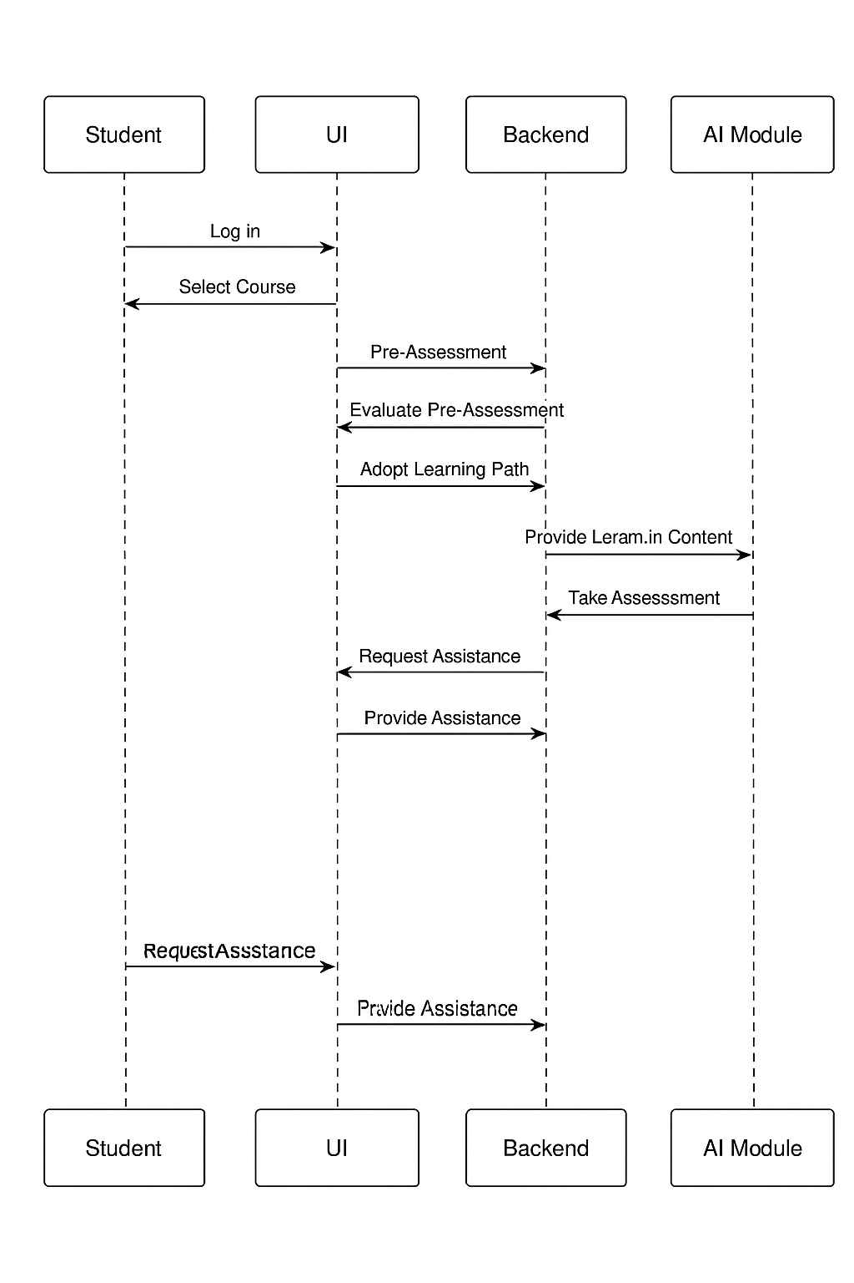

### Use Case Diagram

A Use Case diagram represents the interactions between users (or other systems) and the system itself. It shows the functionalities the system provides and how different users can interact with it.

**Actors:**

* **End User**: A non-technical user interacting with the system for receiving alerts and instructions.
* **Admin**: A system administrator responsible for configuring the system and monitoring overall performance.

**Use Cases:**

* **Monitor System**: The system continuously monitors activities and network traffic.
* **Detect Attack**: The system detects potential cyber threats, such as phishing, unauthorized access, or malware.
* **Guide User**: The system provides guidance to the user, explaining the attack and suggesting mitigation steps.
* **Learn from Incidents**: The system uses historical data to improve future threat detection.

**CHAPTER-5**

**Proposed AI-Driven Security Solution**

**5. Proposed AI-Powered Personalized Learning Platform**

**5.1 Overview of the Personalized Tutor System**

The AI-Powered Personalized Learning Platform dynamically adapts to each student's knowledge level using AI models. It provides customized learning paths, adaptive content, and real-time doubt assistance.

**5.2 Core Functionalities**

* **5.2.1 Adaptive Learning Module** – Adjusts course difficulty based on pre-assessment and ongoing performance.
* **5.2.2 AI-Based Content Recommendation System** – Suggests study materials based on student progress.
* **5.2.3 Real-Time Student Performance Analysis** – Continuously tracks and updates the learning path based on assessment scores.

**5.3 Working Mechanism**

1. **Student logs in** and selects a course.
2. **Pre-assessment** evaluates prior knowledge.
3. **AI adapts content** based on assessment results.
4. **Ongoing assessments** adjust the learning path dynamically.
5. **Doubt assistance system** helps via chat or voice interaction.
6. **Performance monitoring** ensures progression at the right difficulty level.

**CHAPTER-6**

**Implementation**

### ****Implementation****

#### **6.1 Architectural Overview**

The **AI-powered personalized learning platform** is designed to run locally, adapting course content dynamically based on student performance. It integrates multiple modules for adaptive learning, real-time feedback, and interactive tutoring.

**6.2 Data Collection & Model Training**

* The system collects student data from **pre-assessments, module assessments, and engagement patterns**.
* Machine learning techniques analyze **student strengths, weaknesses, and learning styles** to personalize recommendations.

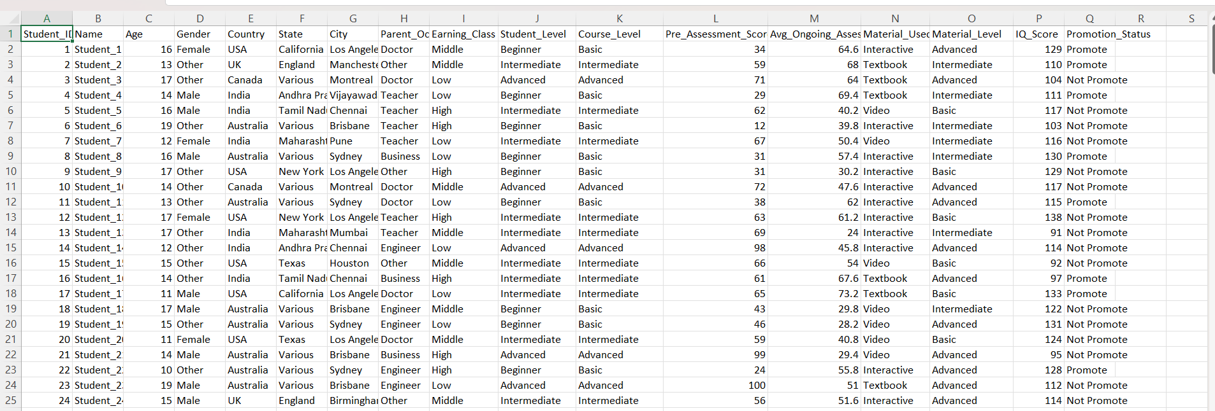

**6.3 AI Model Training for Adaptive Learning**

* AI is trained on **educational datasets and past student interactions** to predict student performance and recommend personalized learning paths.
* The system uses **classification algorithms** to determine whether a student should receive **basic, intermediate, or advanced content**.

**6.4 System Development**

**6.4.1 Adaptive Learning Engine**

* Adjusts **course difficulty levels** based on the student’s past assessment scores.
* Uses **reinforcement learning** to optimize content delivery.

**6.4.2 Content Recommendation Module**

* Suggests **videos, notes, and quizzes** based on learning progress.
* Uses **NLP techniques** to recommend materials matching the student’s weaknesses.

**6.4.3 Student Performance Analysis Module**

* Tracks **quiz scores, assignment completion rates, and engagement levels**.
* Provides **visual analytics** for students to monitor their progress.

**6.4.4 AI-Powered Feedback System**

* Uses AI to generate **personalized feedback** on student progress.
* Provides **automated tips** to improve weak areas.

**6.5 User Interface Development**

**6.5.1 Designing an Interactive Dashboard**

* Displays **student progress, assessment scores, and suggested materials**.
* Provides a **clean and intuitive interface** for easy navigation.

**6.5.2 Implementing a Voice and Text-Based Tutor**

* Students can interact via **chatbot or voice assistant** for **doubt resolution and course navigation**.
* Uses **speech-to-text and text-to-speech** for hands-free learning support.



**6.6 Real-Time Learning Assistance**

* AI provides **instant responses to student queries**.
* Live assistance for **doubt resolution and performance tracking**.
* Uses **AI-driven alerts** to notify students about weak topics and suggested improvements.

**CHAPTER-7**

**Testing and Debugging**

**7. Testing and Debugging**

7.1 Simulating Different Learning Scenarios

To ensure the AI-powered personalized learning platform functions optimally, various learning scenarios were simulated:

* Beginner-Level Student: The AI assigns basic-level course content and gradually increases difficulty.
* Intermediate-Level Student: The AI customizes the learning path based on pre-assessment scores and adjusts modules dynamically.
* Advanced-Level Student: The AI skips foundational topics and directly assigns advanced materials.
* Low-Performing Student: The system provides additional practice material and personalized feedback to improve performance.

7.2 User Testing and Feedback

User testing was conducted with different types of learners, including:

* School and college students to assess ease of use and effectiveness.
* Teachers and subject matter experts to evaluate content recommendation accuracy.
* EdTech professionals to validate system efficiency.

Feedback collected included:

* Interface usability (ease of navigation).
* Accuracy of AI-driven recommendations.
* Effectiveness of real-time doubt assistance.

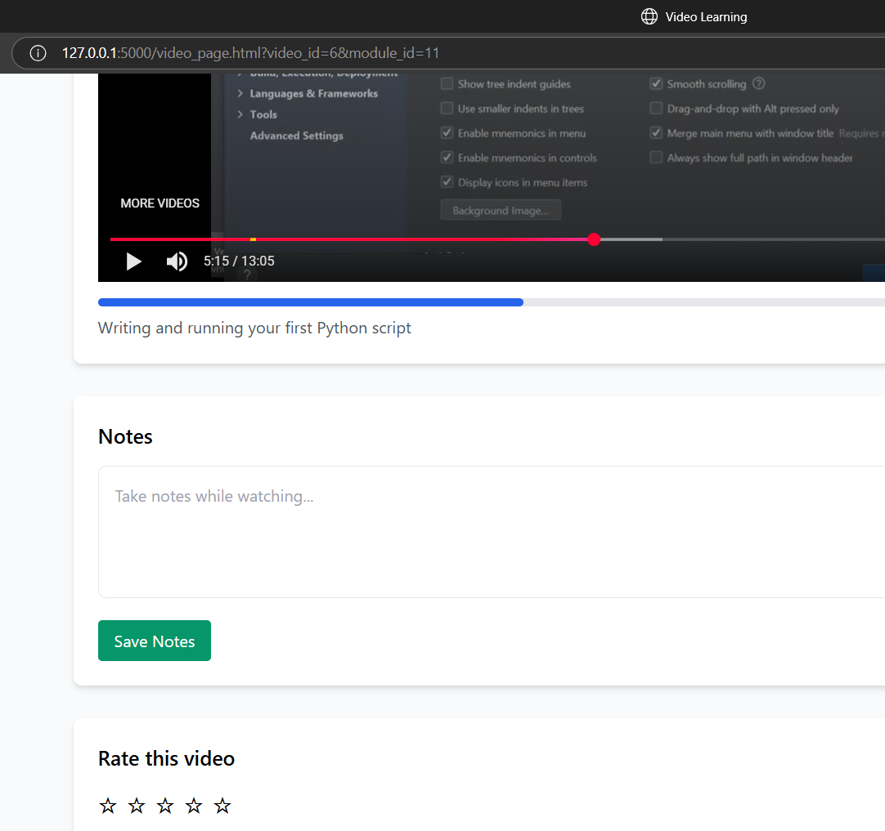

7.3 Performance Evaluation of AI Recommendations

The AI recommendation system was tested based on:

* Accuracy: How well the AI matches course modules to student skill levels.
* Response Time: The time taken to generate recommendations and feedback.
* User Satisfaction: Measured through feedback surveys on the relevance of AI-suggested content.

The system was further optimized based on test results, refining learning pathways, assessment difficulty levels, and real-time assistance accuracy.

**CHAPTER-8**

EXPERIMENTATION & RESULT ANALYSIS

* 1. **Output Screens / Results**

**8.1.1 Personalized Learning Paths**

The AI-powered personalized tutor dynamically adapts to students’ prior knowledge and learning pace. Key aspects of the personalized learning path include:

* Pre-Assessment Analysis: Determines a student’s existing knowledge and classifies them into Beginner, Intermediate, or Advanced levels.
* Customized Learning Modules: Based on the pre-assessment results, students are assigned modules that match their proficiency.
* Progressive Learning Flow: Students must complete assessments at each stage to unlock the next module, ensuring steady progress

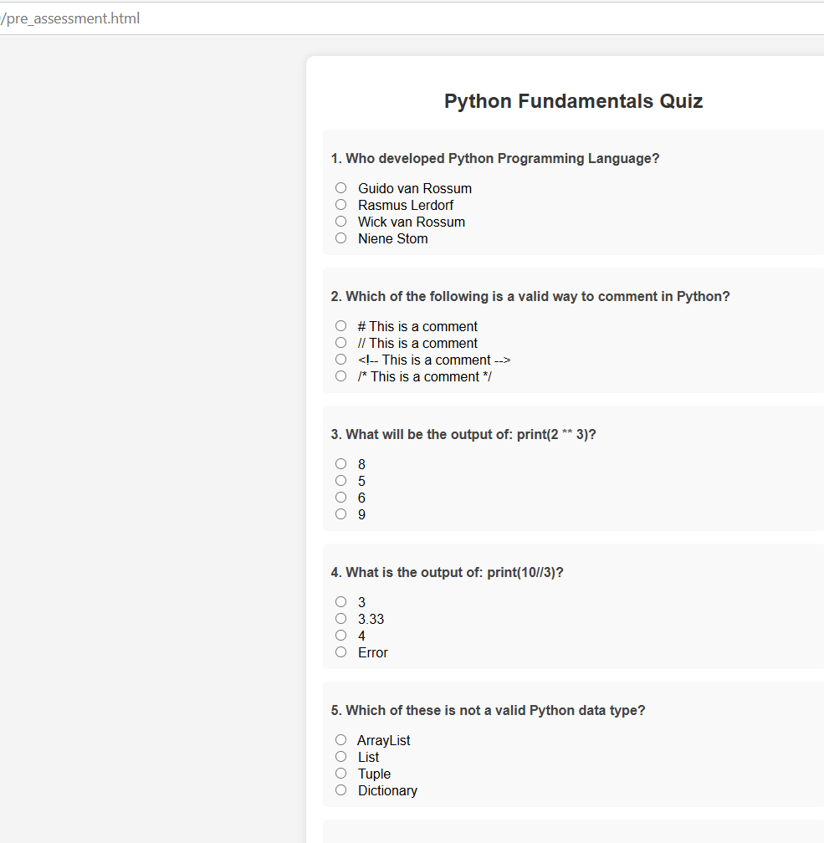

**8.1.2 Adaptive Content Delivery**

The platform ensures an **adaptive learning experience** through:

* **AI-Based Content Recommendation:** Suggests relevant materials, videos, and quizzes based on individual student progress.
* **Difficulty Level Adjustment:** The AI model modifies quiz and assessment difficulty dynamically based on past performance.
* **Performance-Driven Module Unlocking:** Students who score higher on assessments gain access to more advanced modules, while those struggling receive extra practice material.

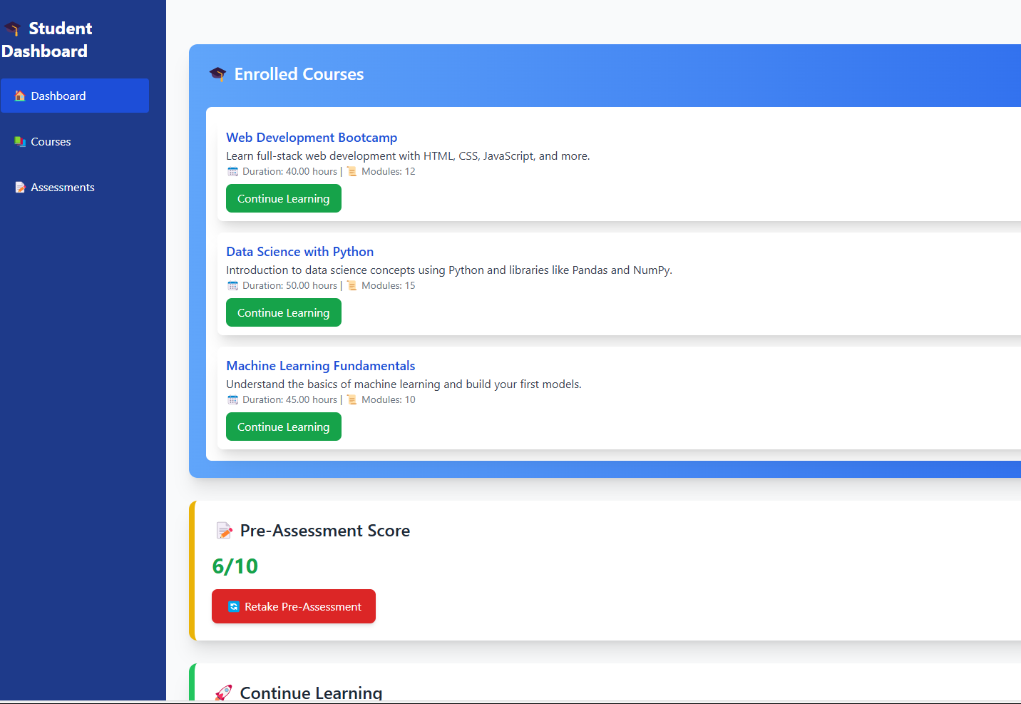

**CHAPTER-9**

**Conclusion and Future Enhancements**

## Conclusion and Future Enhancements

* 1. **Summary of the Project**

The AI-powered personalized learning platform revolutionizes digital education by providing **adaptive learning paths, AI-driven content recommendations, and real-time performance analysis**. The system personalizes course modules based on pre-assessment results, ensuring that each student learns at an appropriate level. By integrating **real-time student progress tracking, adaptive quizzes, and AI-powered assistance**, the platform enhances engagement and learning efficiency. The implementation of a **voice and text-based tutor** further improves accessibility and ease of use.

Through testing and experimentation, the platform demonstrated significant improvements in **student engagement, course completion rates, and learning effectiveness**. The AI-driven recommendation system successfully adjusted content difficulty based on performance, making learning more dynamic and effective.

**9.2 Limitations**

While the platform offers significant improvements in personalized education, it has some limitations:

* **Limited Dataset for AI Training:** The accuracy of adaptive learning depends on the training data. A **small dataset** may result in less effective recommendations.
* **Dependency on Initial Assessments:** If the pre-assessment test does not accurately gauge a student's prior knowledge, the adaptive learning path might not be optimal.
* **Lack of Human Tutoring Integration:** While AI provides real-time guidance, **human intervention** for complex queries and mentorship is limited.
* **Hardware and Processing Limitations:** Since the system runs **locally (without cloud integration)**, it requires good computing power for AI processing and analytics.
  1. **Future Enhancements**

To overcome current limitations and further improve the system, the following enhancements can be implemented:

Enhanced AI Model with Larger Dataset: Expanding the dataset will help improve the AI’s accuracy in recommending personalized learning paths.

Hybrid Learning Approach: Integrating human tutors with AI-powered learning for a more balanced and interactive learning experience.

Cloud-Based Expansion: Shifting from a local-only system to a cloud-based platform will allow better data management, scalability, and real-time analytics.

Gamification Elements: Adding badges, leaderboards, and rewards can increase student motivation and engagement.

Multilingual Support: Enhancing the AI assistant to support multiple languages, making learning more accessible globally.

Advanced Analytics Dashboard: Implementing AI-powered insights that provide students and educators with detailed performance analytics, improvement suggestions, and engagement tracking.

**CHAPTER-9 CONCLUSION**

### Conclusion

1. The AI-powered **Personalized Learning Platform** successfully addresses the challenges of traditional learning by offering **adaptive learning paths, AI-driven content recommendations, and real-time student performance analysis**. The system dynamically tailors educational content based on each learner’s needs, ensuring an **efficient, engaging, and interactive** learning experience.
2. Through implementation and testing, the platform demonstrated **improved learning outcomes** by adjusting content difficulty, providing AI-powered guidance, and offering an interactive dashboard for students. The **integration of voice and text-based assistance** further enhanced accessibility and usability.
3. While the system performs effectively in delivering personalized education, **further enhancements** such as **cloud integration, human-AI hybrid tutoring, multilingual support, and gamification** can improve its scalability and engagement.
4. Overall, this project establishes a **strong foundation for AI-driven education** and highlights the potential of intelligent systems in revolutionizing learning methodologies.